Deploy sample Web App in K8s

Version | Created By | Date | Log
1 | Gunal Sriram R | 2022-01-02 | First version

Step 1:
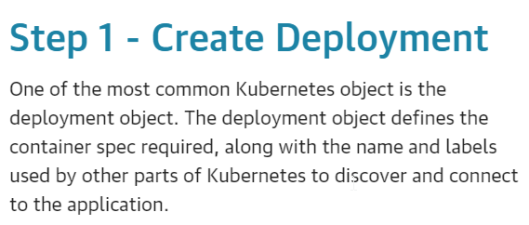
- The definition defines how to launch an application called webapp1 using the Docker Image katacoda/docker-http-server that runs on Port 80.

apiVersion: apps/v1
kind: Deployment
metadata:
name: webapp1
spec:
replicas: 1
selector:
matchLabels:
app: webapp1
template:
metadata:
labels:
app: webapp1
spec:
containers:
- name: webapp1
image: katacoda/docker-http-server:latest
ports:
- containerPort: 80

- This is deployed to the cluster with the command
kubectl create -f deployment.yaml
- As it's a Deployment object, a list of all the deployed objects can be obtained via
kubectl get deployment
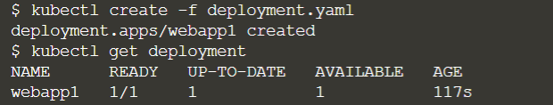
- Details of individual deployments can be outputted with
kubectl describe deployment webapp1
Step 2:
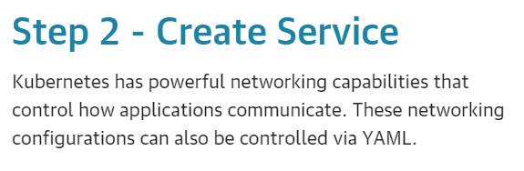
- Copy the Service definition to the editor. The Service selects all applications with the label webapp1. As multiple replicas, or instances, are deployed, they will be automatically load balanced based on this common label. The Service makes the application available via a NodePort.

apiVersion: v1
kind: Service
metadata:
name: webapp1-svc
labels:
app: webapp1
spec:
type: NodePort
ports:
- port: 80
nodePort: 30080
selector:
app: webapp1

- Deploy the Service with
kubectl create -f service.yaml

- As before, details of all the Service objects deployed with
kubectl get svc
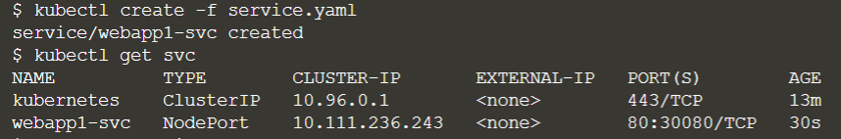
- By describing the object it's possible to discover more details about the configuration
kubectl describe svc webapp1-svc
Step 3:
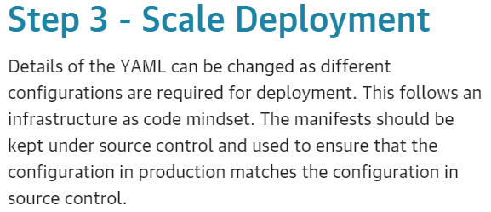
- Update the deployment.yaml file to increase the number of instances running. For example, the file should look like this

apiVersion: apps/v1
kind: Deployment
metadata:
name: webapp1
spec:
replicas: 4
selector:
matchLabels:
app: webapp1
template:
metadata:
labels:
app: webapp1
spec:
containers:
- name: webapp1
image: katacoda/docker-http-server:latest
ports:
- containerPort: 80

- Updates to existing definitions are applied using kubectl apply. To scale the number of replicas, deploy the updated YAML file using
kubectl apply -f deployment.yaml
- Instantly, the desired state of our cluster has been updated, viewable with
kubectl get deployment
- Additional Pods will be scheduled to match the request.
kubectl get pods
- As all the Pods have the same label selector, they'll be load balanced behind the Service NodePort deployed.
- Issuing requests to the port will result in different containers processing the request
curl host01:30080

